**Design Document**

19301014 吕炎明

**Ⅰ、Function Description**

Functional Specification：

Two functions were added to the web front-end,

1. For either index page or book profile page, modify your js code in assignment 3 by, writing ajax code to load page contents from server, and then populate the json contents to the template when the page is loaded or when is necessary.

**Solution：**Functions were written in loadData.js using jQuery’s ajax function. The index.html web pages is converted to template types by reading loadData.js, the web page can automatically load the book commodity information of the shopping web page.

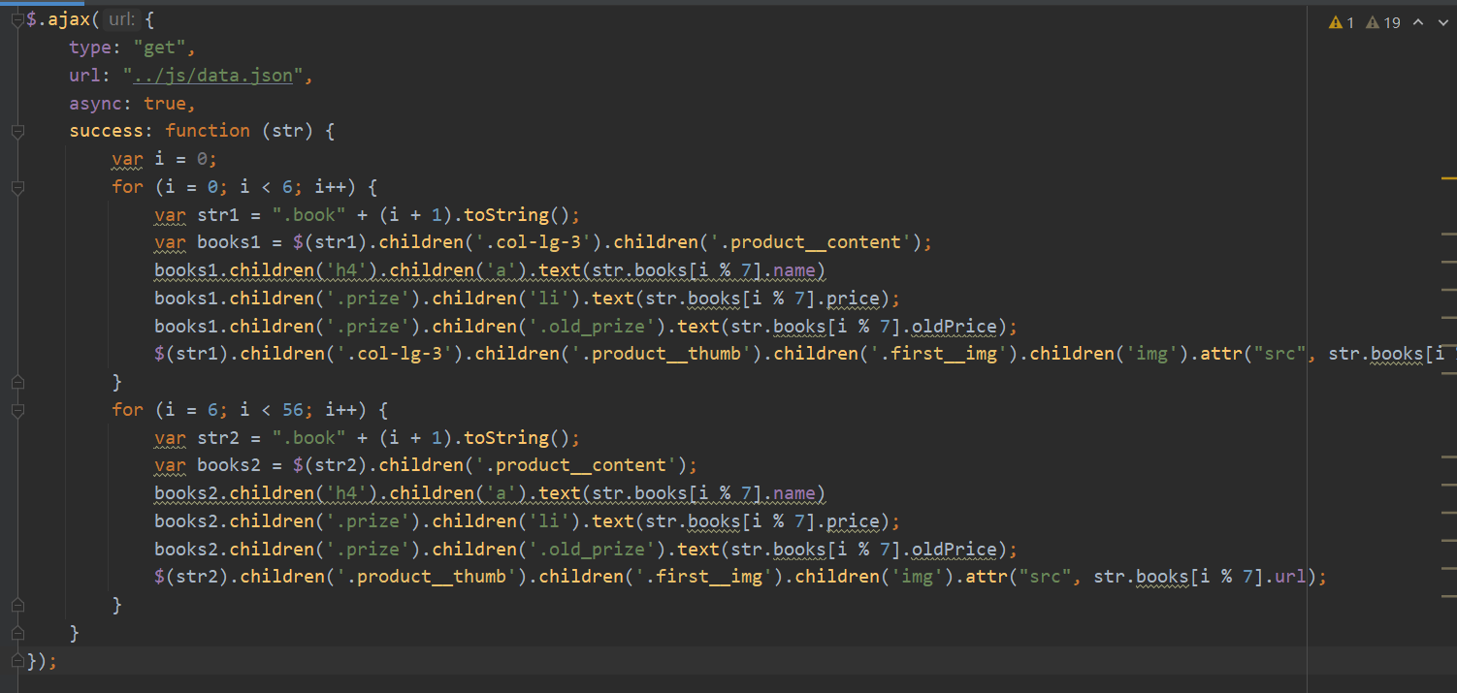

**Use jQuery’s ajax to get json data**

1. Complete the log-in submit function and access control.

**Solution：**Functions were written in loadData.js using jQuery’s ajax function. If the user does not enter information or enters wrong information, the browser will prompt the user after clicking the login or registration button.

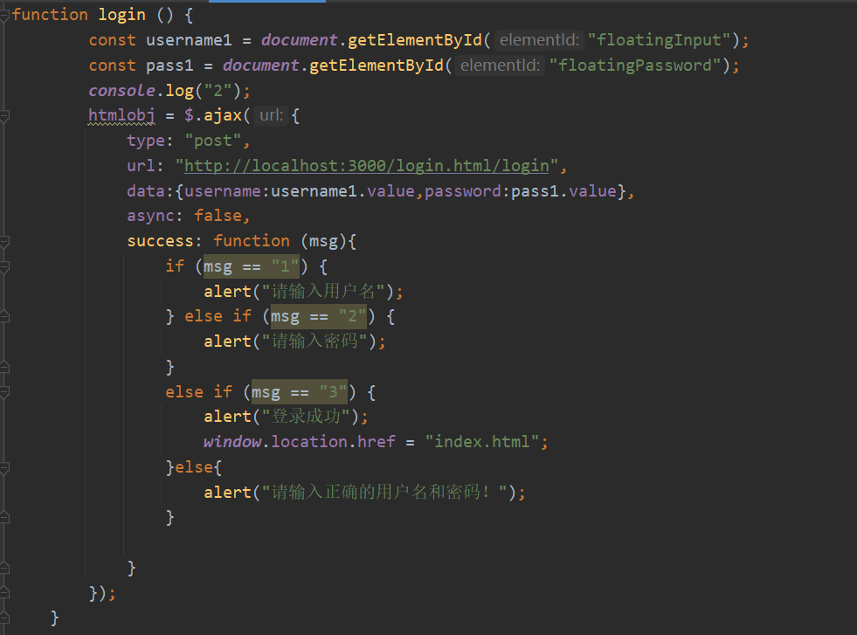

**Use jQuery’s ajax to send json data**

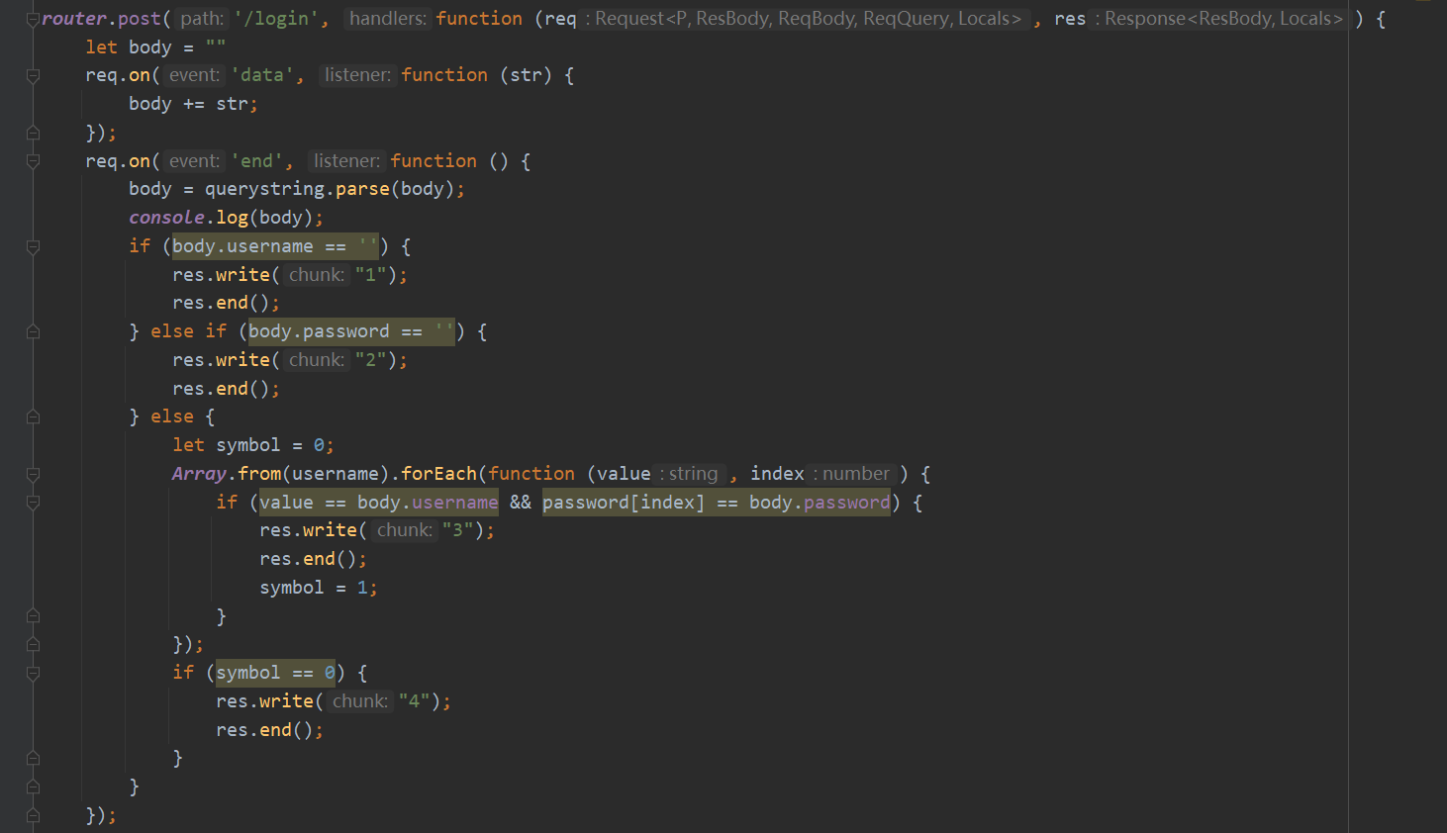

**Listen to POST request and judge the login data**

**Ⅱ、Screenshots Display**

Index.html（web）：



Index.html（mobile）：



description.html（web）：

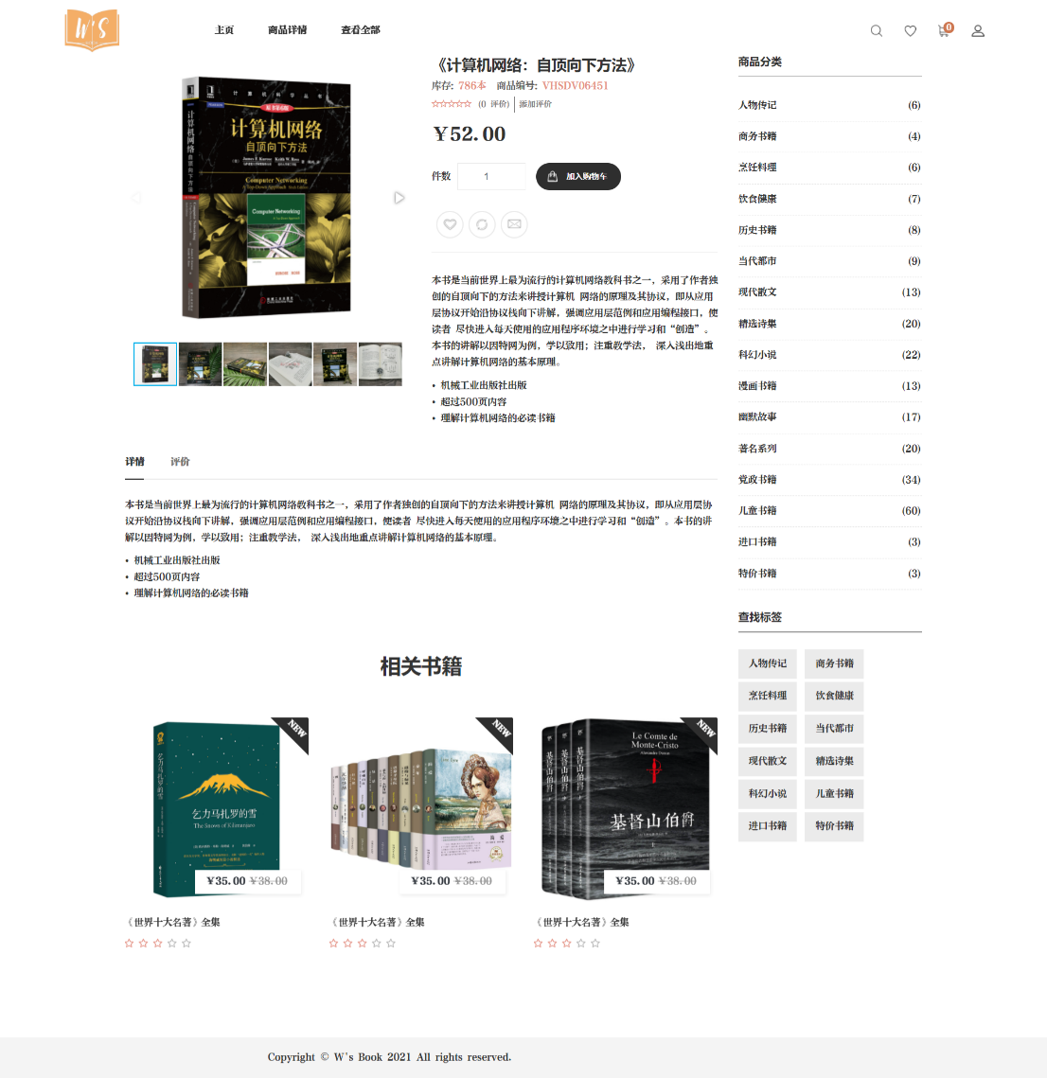

description.html（mobile）：

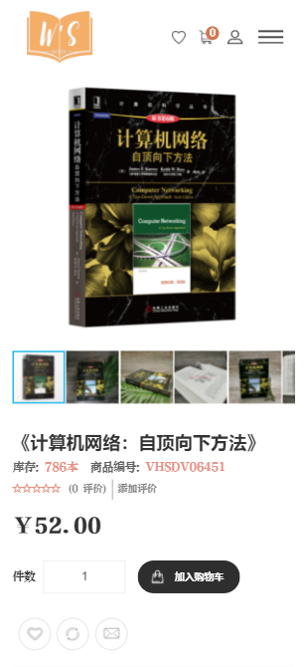

login.html（web）：

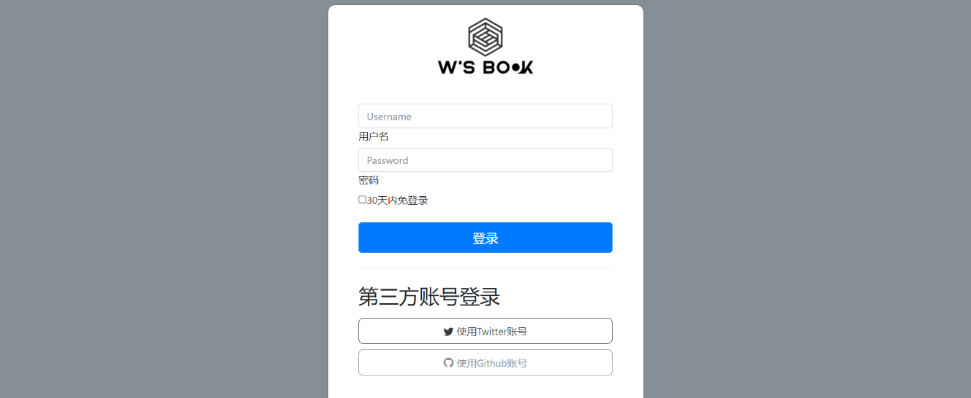

login.html（mobile）：

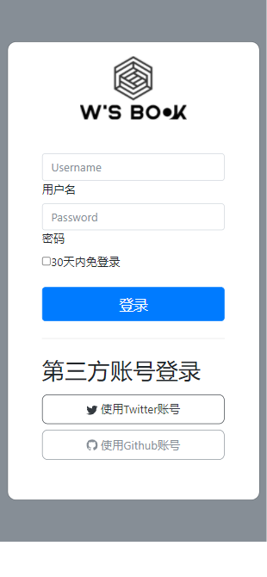

login.html（entering wrong username or password）：

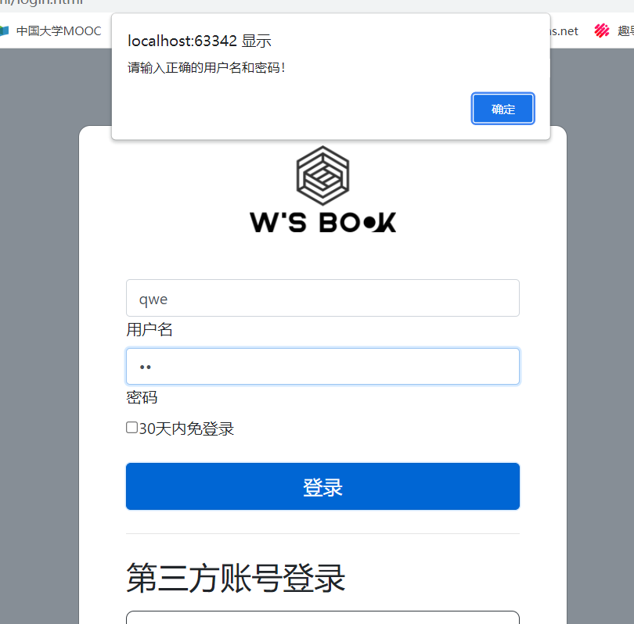

login.html（no input）：

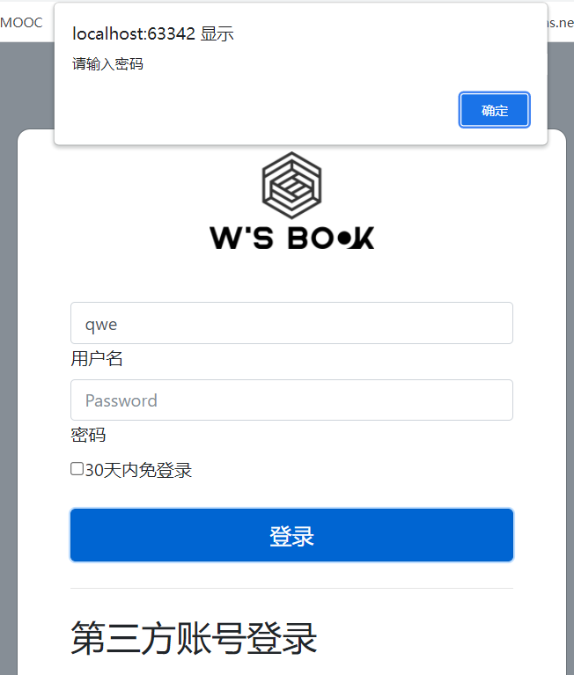

login.html（success）：

